|  |
| --- |
| Name: **N. S. De Alwis** |
| Student Reference Number: **10707160** |



|  |  |  |
| --- | --- | --- |
| Module Code: **PUSL3111** | Module Name: **API Software Development** | |
| Coursework Title: **API Coursework** | | |
| Deadline Date: **11th May 2022** | | Member of staff responsible for coursework: **Dr. Rasika Ranaweera** |
| Programme: **BSc (Hons) Plymouth Software Engineering** | | |
| Please note that University Academic Regulations are available under Rules and Regulations on the University website [www.plymouth.ac.uk/studenthandbook](http://www.plymouth.ac.uk/studenthandbook). | | |
| Group work: please list all names of all participants formally associated with this work and state whether the work was undertaken alone or as part of a team. Please note you may be required to identify individual responsibility for component parts.  **J.A. Mujeeb – 10707284**  **G.M.D.D. Ratnayake – 10707351**  **S.O. Perera – 10707315**  **N. S. De Alwis – 10707160**  **M. D. A. Medhavi – 10707278**  **P. P. L. Dilhani – 10709402**  ***We confirm that we have read and understood the Plymouth University regulations relating to Assessment Offences and that we are aware of the possible penalties for any breach of these regulations. We confirm that this is the independent work of the group.***  Signed on behalf of the group: **N. S. De Alwis** | | |
| Individual assignment: ***I confirm that I have read and understood the Plymouth University regulations relating to Assessment Offences and that I am aware of the possible penalties for any breach of these regulations. I confirm that this is my own independent work.***  Signed: | | |
| Use of translation software: failure to declare that translation software or a similar writing aid has been used will be treated as an assessment offence.  I *have used/not used translation software.  If used, please state name of software………………………………………………………………… | | |
| **Overall mark _____% Assessors Initials ______ Date_________** | | |

*Please delete as appropriateSci/ps/d:/students/cwkfrontcover/2013/14

Table of Contents:

|  |  |  |
| --- | --- | --- |
| Name | Student ID | Contribution |
| J.A. Mujeeb | 10707284 | 16.7% |
| G.M.D.D. Ratnayake | 10707351 | 16.7% |
| S.O. Perera | 10707315 | 16.7% |
| N. S. De Alwis | 10707160 | 16.7% |
| M. D. A. Medhavi | 10707278 | 16.7% |
| P. P. L. Dilhani | 10709402 | 16.7% |

# Acknowledgement -

First and foremost, we’d like to extend our sincere gratitude towards Dr. Rasika Ranaweera, our module lecturer. We are extremely humbled and grateful to have been able to receive his mentorship, guidance, and support.

The overall accomplishment of this project demanded a significant amount of guidance from many individuals. As a team, we are extremely fortunate to have had this from start to finish.

Finally, we wouldn’t have been able to successfully complete this assignment without the hard work and assistance of all the team colleagues itself. We all enjoyed working with each other.

# Abstract

This assignment comprises of a documented report on an API Web Application and Mobile Application, pertinent to the Sri Lanka Bureau of Foreign Employment (SLBFE).

**Coursework Supervisor:** Dr. Rasika Ranaweera

**Group:** Group No. 22

**Deadline:** 23rd of April 2021

**Introduction**

The Sri Lanka Bureau of Foreign Employment (SLBFE) is a government owned foreign employment agency that assists its citizens in the procurement of global employment opportunities.

It is evident that labour is a fundamental asset that would greatly contribute towards substantial job creation, playing a key role in securing a stable source of foreign currency inflow. It also recognizes predicaments related unemployment, helping more Sri Lankans escape the risks of poverty, bestowing the potentiality to further enhance their prosperity and well-being.

Project Scope –

1. Citizens –
2. Bureau Officers (acts as Admin) –
3. Foreign Companies –

.

1. Mobile Application –

* We are able to view available vacancies in the mobile application.
* Both admin and client have the same login.
* PHP

1. Web Application –

* Java
* Client is only able to view profile, complaints, seekers, logout
* In jobs, in the PHP myAdmin Database, there is isvacancy 1 have vacancy or if 2 client qualification update

In DB, if 1 registered it’s a ADMIN if 2 it’s a CLIENT/Student

Users 1 is active 2 is inactive

Client block 1 is active 2 is inactive blocked

Status 1 means user is active.

Status 2 means user is inactive.

when running the admin and client application since they are local host they are run on the typicall local host ports, for admin the port is 127.0.0.1.8000 but in the instance i=of the client the local host port is different 127.0.0.1.8001

the admin of the application is linked with the api therefore the link will be visible as 8000/api/login , but when looking at the clients one the link is 8001/login

AuthController.php (app>Http>controllers)

Mobile app resistration data will be fetched by this controller , Codes related to checking and validating the Login and registering into the app is in this file ,

*Controller - No validation

* Put/post (47.28) time stamp

8000 port is for Admin/API

8001 port is for Posting

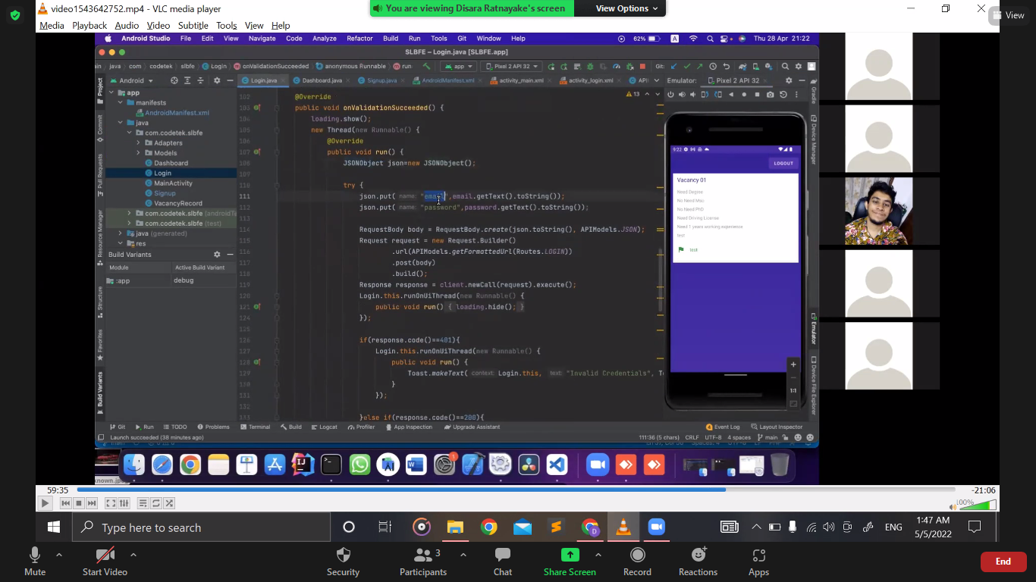

Time stamp – 1:00:00 -> 1:03

*json serialization [very important]

*recycle view – used to clear up memory space [1:03:30]

Review json and xml (how it happens)

*Adapter – Design Pattern

Individual Contribution –

1. J.A. Mujeeb (10707284) -
2. G.M.D.D. Ratnayake (10707351) -
3. S.O. Perera (10707315) -
4. N. S. De Alwis (10707160) -
5. M. D. A. Medhavi (10707278) -
6. P. P. L. Dilhani (10709402) -